

FACULTY OF TECHNOLOGY AND ENGINEERING
DEVANG PATEL INSTITUTE OF ADVANCED TECHNOLOGY AND RESEARCH

DEPARTMENT OF INFORMATION TECHNOLOGY

A.Y 2026-27 Semester-3

LAB MANUAL

CSUC201: Fundamentals of Data Structure and Algorithms



Practical 9
Practical AIM:
To implement depth-first and breadth-first traversal on a graph and develop the ability to reason about how the order of exploration changes depending on the traversal strategy used.
Practical 9.1
Problem definition:
A disaster relief team needs to inspect all buildings in a city after an earthquake. The city is mapped as a network where buildings are connected by roads. One team starts at a building and goes as deep into each road as possible before backtracking, while a second team spreads out level by level — first checking all buildings directly connected to the start, then all buildings two roads away, and so on. Given the city map as a graph and a starting building, implement both exploration strategies and print the order in which buildings are visited by each team.
Describe how the order of buildings visited differs between the two strategies on the same graph. What data structure does each strategy rely on to decide which building to visit next, and how does that structure cause the difference in order?
Problem faced:
I faced difficulty while implementing DFS and BFS because both visit graph nodes in different orders.
Solution:
I used recursion for DFS to explore one path deeply before backtracking. For BFS, I used a queue to visit neighboring nodes level by level. I also used a visited array to avoid visiting the same node more than once.
Output:
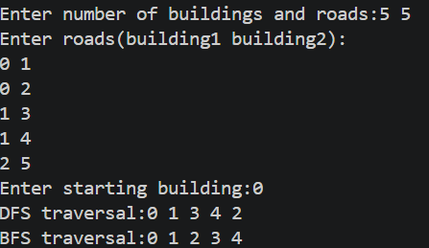
Key Questions
1. [Problem 1] Both strategies visit every reachable node exactly once. If the goal is simply to check whether a specific building exists in the network, which strategy would find it sooner if the building is very close to the start? What if it is very far and deep? Explain your reasoning without tracing through any specific example.
ANS:
If the building is close to the starting point, BFS may find it sooner because it visits nearby nodes first. If the building is very far and deep along a particular path, DFS may find it sooner if it explores that path first. However, DFS does not guarantee that it will find the far building sooner because its order depends on the graph's connections and the order in which neighbors are explored.
2. [Problem 1] Your DFS implementation likely uses recursion. What real-world constraint on the computer could cause your recursive DFS to fail on a very large city map, and how would you restructure your solution to avoid that failure?
ANS:
Recursive DFS may fail because of a stack overflow when the recursion becomes too deep. This happens when the computer's call stack runs out of available memory. To avoid this, I can implement DFS iteratively using an explicit stack instead of recursion.
Github link:
https://github.com/dhanvi-219/FDSA/tree/main/Practical%209

